Globus family of brands
Offer: Earn a $100 Amazon E-Gift Card for any new 2026:
- Avalon Active & Discovery Sailing
- Globus Rail Vacations

T&C’s:
Valid for all bookings deposited Feb. 1-28, 2026, for 2026 travel. Incentive is payable to advisor with Amazon E-Gift Card. This is in addition to TLN Exclusive Offers, Avalon Complimentary Pre-Paid Gratuities and Globus TLN Rail Vacations $100 pp. *Maximum redemption of Amazon E-Gift Cards is for the first (10) bookings submitted per agency.
To Redeem:
Book and deposit new Avalon Active & Discovery Sailing or Globus Rail Vacation.
Email invoice # to: Michael Lawson, Sr. Account Manager National & Strategic Accounts – mlawson@globusfamily.com
Gift Cards will be processed within 7-10 days of submission and sent electronically to advisor.

AmaWaterways
Offer Terms/Eligibility | Promotion Details
Promotion Name | President's Circle Offer: Laundry
Offer - Double Occupancy | 1 Bag of Comp Laundry
Offer - Single Occupancy | 1 Bag of Comp Laundry
Validity Date | January 1 - March 31, 2026
Applicable Departures | Hot Dates
Applicable Categories | All
Applicable Agencies/Consortia | ​TLN President's Circle
Restrictions/Black Out Dates/Notes | Combinable with Retail Offers & TLN Programs
Applicable to FIT Bookings | Yes
Applicable to Group Bookings | Yes
Combinable with Group Discounts | Yes
Applicable to International (USD) Bookings | No
Applicable to Tour Operators Bookings | No
Applicable Markets/Currencies  (All, USD, CAD, EUR, GBP, AUD, NZD) | USD/CAD
Commission Restrictions | No
Applicable to Smithsonian Sailings | No
Combinable with SJ Discounts | No
Combinable with AirPlus | Yes
Combinable with Past Guest | Yes
Combinable with Referral Program  (REF21, PGREF21, REF22) | Yes
Combinable with Future Cruise Benefit (FCB) | Yes
Combinable with Retail offers (EBR, SAVE, WINE, FREELAND, TRIPLESAVING, FLYFREE, etc.) | Yes
Combinable with Solo Offers (SOLO25, SOLO-25, SOLO10, etc.) | Yes
Combinable with TLN Amenity Program | Yes
Combinable with TLN Hosted Program | Yes
Combinable with TLN AmaMax Program | Yes
Combinable with AMEX Privelege Program (AMEXCPP) | Yes
Combinable with Jumpstart/Upgrade Rewards | N/A
Combinable with CLIA offers (CLIA25, CLIA50, CLIA50-AGENT, CLIA50-AGENCY) | Yes
Combinable with Back to Back/Combo Savings (10%) | Yes
Combinable with Loyalty Cruise Offers | Yes
Combinable with Military $250 off Offer | Yes
Combinable with Military Offers (2for1/10% sgl sup) | No
Combinable with industry rates  (FAM, INTERLINE, FRIENDS & FAMILY, etc.) | No
BDM Promo Codes | No
Promo Code | TLN-PC LDRY
Manual Apply OR Auto Apply | Auto Apply
Bookable on TA Portal - Online Booking Engine (OBE) | Yes
Bookable on Cruise Booking Engine (CBE) | No

Royal Caribbean
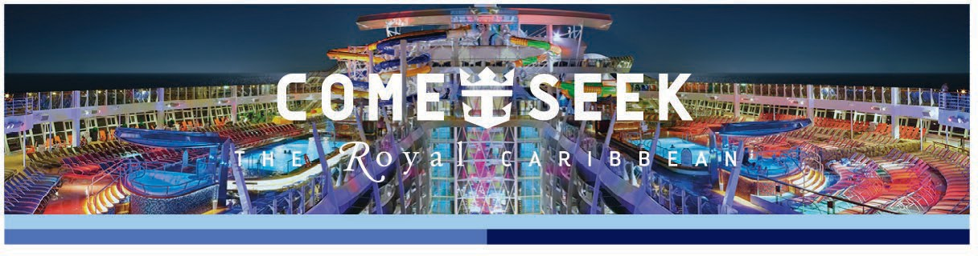

R Royal Caribbean President’s Circle Exclusive Offer
4178884488
SPECIALTY DINING EXPERIENCE FOR TWO
BOOKING WINDOW | February 1 – February 28, 2026
OFFER DETAILS | Book a Balcony or Suite and receive a specialty dining experience for two
APPLICABLE SAILINGS AND CATEGORIES | Balcony or Suite on 6-night or longer Caribbean, Bermuda, Bahamas & West Coast/Mexico sailings departing April 1, 2026 – September 30, 2026
BOOKING PROCEDURES | - Bookings can be made via the phone by calling Royal Caribbean Reservations at 1-800-327-6700, online at www.cruisingpower.com via Espresso, or your regular GDS  - All redemptions must be submitted via the below form by March 2, 2026: https://forms.office.com/r/6mYi7jTApB  - Royal Caribbean will apply specialty dining to all eligible reservations by March 16, 2026  - Voucher will be included within guest documents (eDocs) as early as 49 days prior to sailing  - Contact your Sales Support Specialist or TLNSupport@rccl.com if you have any questions  - We reserve the right to disallow any credit for inappropriately duplicative submissions, or those that are inconsistent with the terms and conditions of the offer
TERMS AND CONDITIONS | Specialty dining experience for two applies to new bookings created 2/1/26 – 2/28/26 on 6-night or longer Caribbean, Bermuda, Bahamas & West Coast/Mexico sailings departing 4/1/26-9/30/26, in balcony or above stateroom categories. Offer includes one complimentary specialty dining experience per stateroom for two guests. Offer is valid for lunch for two, one per sailing, at Chops Grille, Giovanni’s Table, Jamie’s Italian or Sabor Modern Mexican; or dinner for two, one per sailing, at Chops Grille, Giovanni's Table, Samba Grill, Jamie’s Italian, 150 Central Park, Wonderland or Hooked Seafood. Offer is not valid at Izumi Hibachi or Izumi Asian Cuisine. Venues vary by ship. Reservations for specialty dining offers must be made onboard. Offer may be used on any day based on venue availability. Revenue items shown on specialty dining menus are not included in this offer and are available at an additional cost. Special dining events that take place in Specialty restaurants are excluded from the specialty dining offer. Offer cannot be used toward the purchase of specialty dining packages. Alcoholic beverages and sodas are not included and are available at an additional cost. Specialty dining gratuities are included. This offer does not give guest(s) any priority for reservations, or if there is a wait to be seated in the restaurant. Offer is not combinable with other specialty dining offers or with the following rates, including, but not limited to, Incentive Groups, Affinity Groups, Interline, Travel Agent, Travel Agent Friends & Family, Net rates, or Casino rates. This offer is only valid for bookings created by the agency within the specified booking window; it does not apply to bookings transferred to the agency after the booking period has ended. Offer open to residents of US, Canada, Puerto Rico and select countries in the Caribbean. Offer is subject to availability and change without notice, capacity controlled, and may be withdrawn at any time. Royal Caribbean International reserves the right to correct any errors, inaccuracies or omissions, disallow any redemption or inappropriately duplicative submissions, or those that are inconsistent with the terms and conditions of the offer, and to change or update fares, fees and surcharges at  any time without prior notice. ©2026 Royal Caribbean Cruises Ltd. Ships’ registry: Bahamas.

